NAME- AASTHA SUDAN
ROLL NO.-2400290100004
DEVOPS MSE1 SUBMISSION

GitHub repository URL :- AasthaSudan/github-skills-challenge
Pull request URL used to validate the workflows :- Verify Python test workflow by AasthaSudan · Pull Request #3 · AasthaSudan/github-skills-challenge

Screenshot showing the GitHub Actions workflows:-
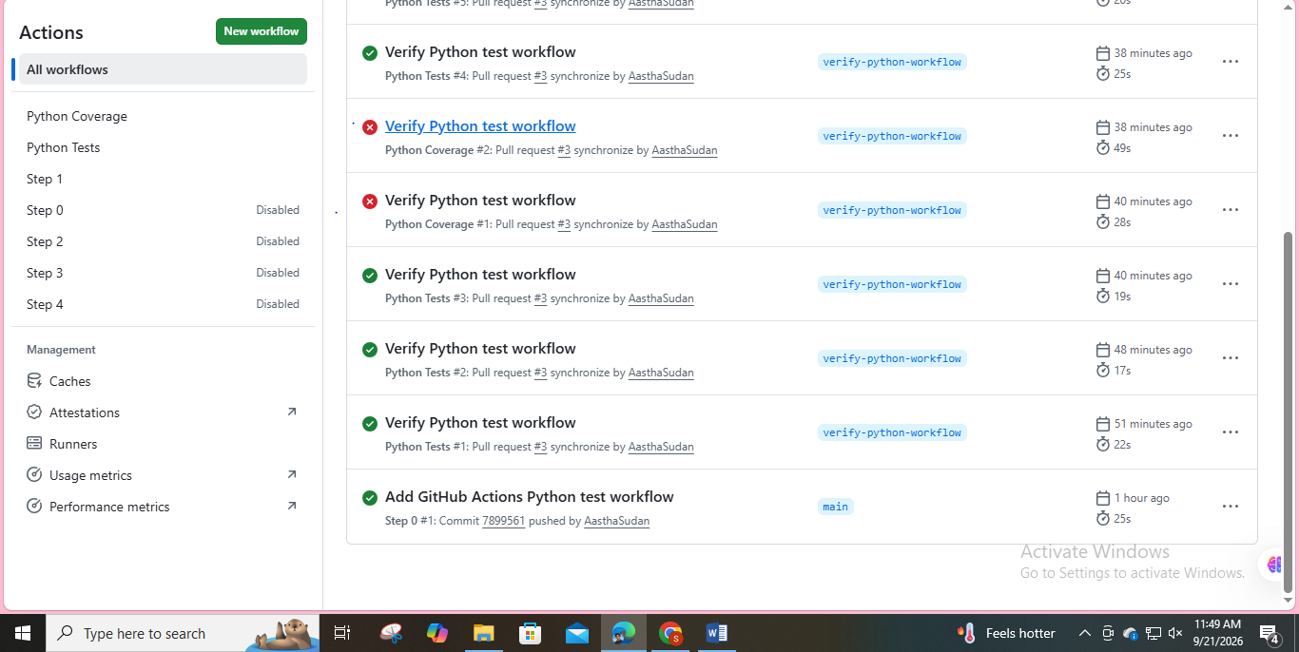

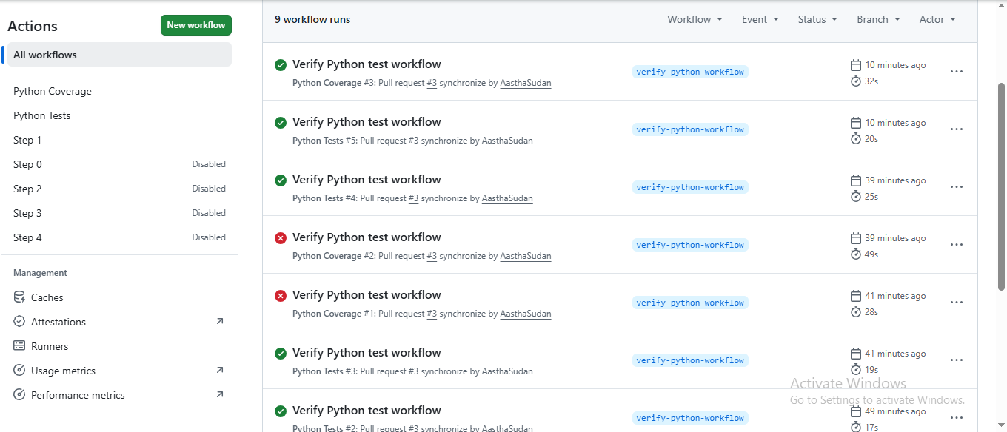

Screenshot showing a successful test workflow execution:-

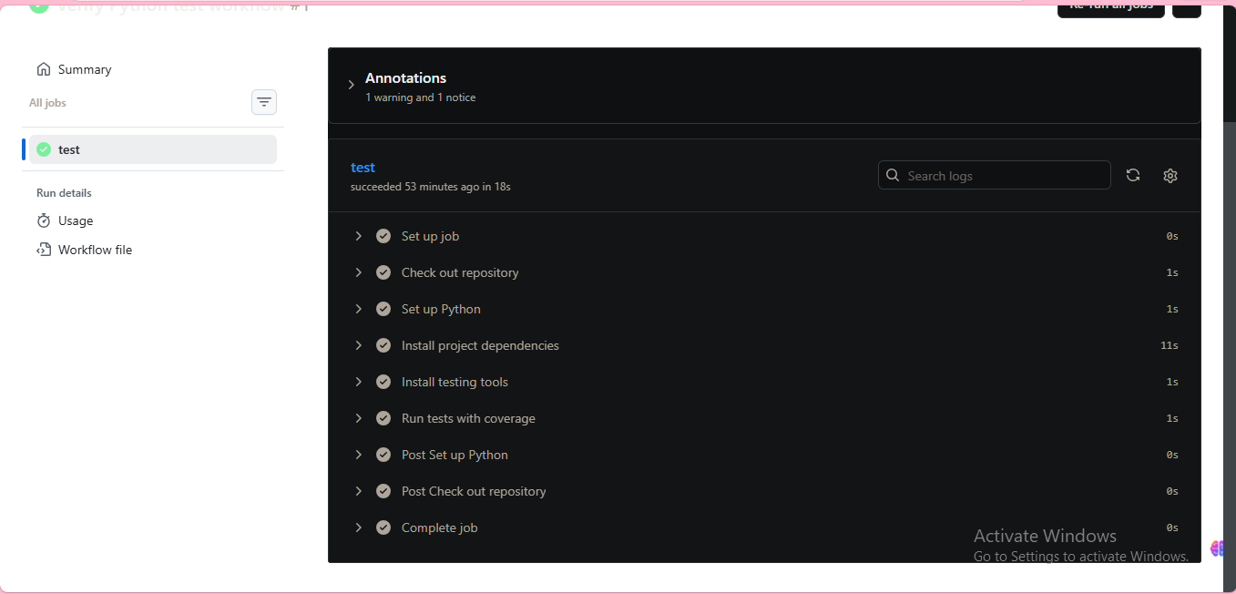

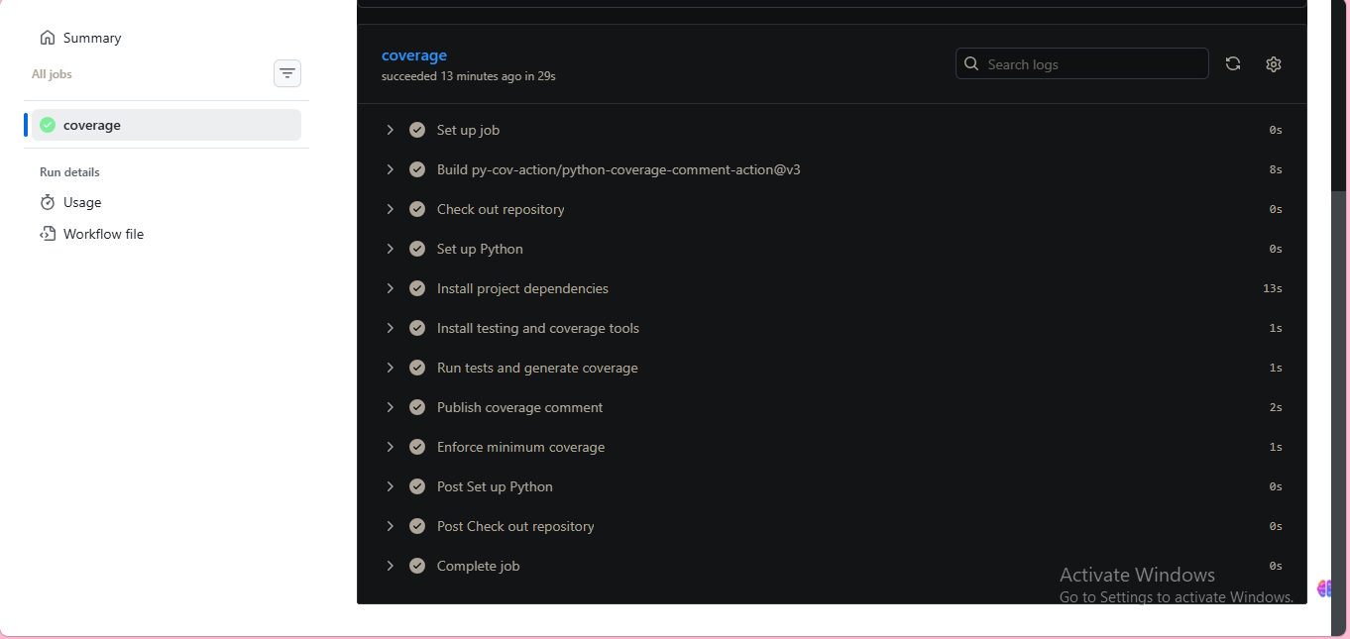

Screenshot showing the coverage result/comment on the pull request:-
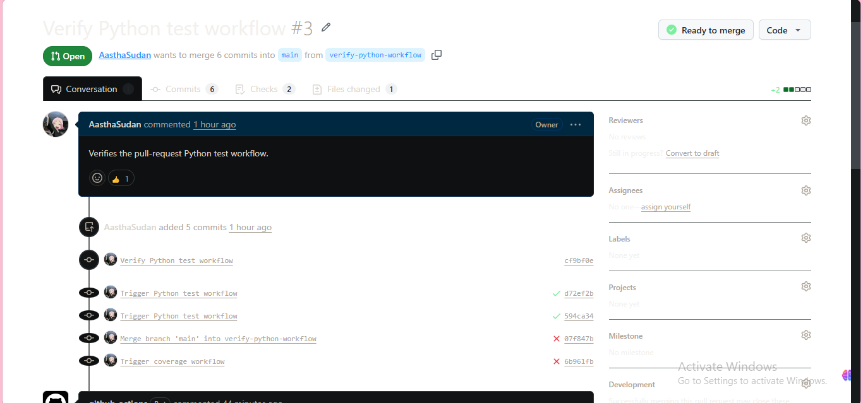

Screenshot showing the final repository/workflow files:-
1)name: Python Tests

on:
pull_request:
branches:
- main

jobs:
test:
runs-on: ubuntu-latest

steps:
- name: Check out repository
uses: actions/checkout@v4

- name: Set up Python
uses: actions/setup-python@v5
with:
python-version: "3.13"

- name: Install project dependencies
run: |
python -m pip install --upgrade pip
python -m pip install -r requirements.txt

- name: Install testing tools
run: |
python -m pip install pytest coverage pytest-cov

- name: Run tests with coverage
run: |
PYTHONPATH=. python -m pytest -vv \
--cov=src \
--cov-report=term-missing

2)name: Python Coverage

on:
pull_request:
branches:
- main

permissions:
contents: read
pull-requests: write

jobs:
coverage:
runs-on: ubuntu-latest

steps:
- name: Check out repository
uses: actions/checkout@v4

- name: Set up Python
uses: actions/setup-python@v5
with:
python-version: "3.13"

- name: Install project dependencies
run: |
python -m pip install --upgrade pip
python -m pip install -r requirements.txt

- name: Install testing and coverage tools
run: |
python -m pip install pytest coverage pytest-cov

- name: Run tests and generate coverage
continue-on-error: true
run: |
PYTHONPATH=. python -m pytest -vv \
--cov=src \
--cov-report=term-missing \
--cov-report=xml \
--cov-fail-under=50

- name: Publish coverage comment
if: always()
uses: py-cov-action/python-coverage-comment-action@v3
with:
GITHUB_TOKEN: ${{ github.token }}

- name: Enforce minimum coverage
run: |
PYTHONPATH=. python -m pytest \
--cov=src \
--cov-report=term \
--cov-fail-under=50

